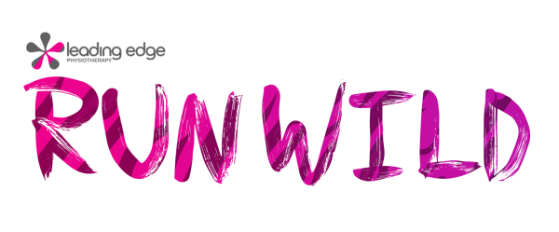
Tax receipts:
• Will be issued for donations of $10 or more.
• Will be issued by February 29, 2020.
• Can only be issued if information is complete and legible.
• For assistance, email info@runwild.ca.

Please make all cheques payable to:
Leading Edge Running Club Ltd.
Make your online donation at www.RunWild.ca

Pledge Form
LIONS PARK, ST. ALBERT, AB Fundraiser’ Name: _________________________
MAY 5, 2019 Fundraiser’s Phone #: ____________________
Name |  | Street Address |  | Email address
Donation amount  $ | City | Postal Code | Phone Number | - I would like to receive updates regarding Leading Edge Physiotherapy RunWild via email.
Name |  | Street Address |  | Email address
Donation amount  $ | City | Postal Code | Phone Number | - I would like to receive updates regarding Leading Edge Physiotherapy RunWild via email.
Name |  | Street Address |  | Email address
Donation amount  $ | City | Postal Code | Phone Number | - I would like to receive updates regarding Leading Edge Physiotherapy RunWild via email.
Total (this page)  $ | We do not sell, rent, or trade our donor lists. We collect, use, and disclose personal information only for the purpose of processing donations and keeping you informed about the activities of Leading Edge Physiotherapy RunWild and the two charities involved. By providing your information, you give the aforementioned organizations consent to maintain contact with respect to this event. **In order for RunWild to communicate with you via email and continue sending you electronic news and information pertaining to Leading Edge Physiotherapy RunWild, we require your expressed consent to ensure we are in compliance with the government’s existing privacy legislation and new anti-spam legislation that took effect January 15, 2015.

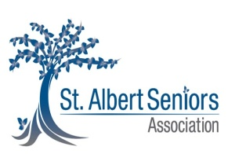
Supporting 3 local charities:

